**Lab sheet 11 – Text Summarization**

Kavishka Gamage – 17000475

**Key Phrase Extraction**

Collocations N-grams (Bigram and Trigram)



NLTK built in collocation with raw frequency and PMI (Pointwise Mutual Information)

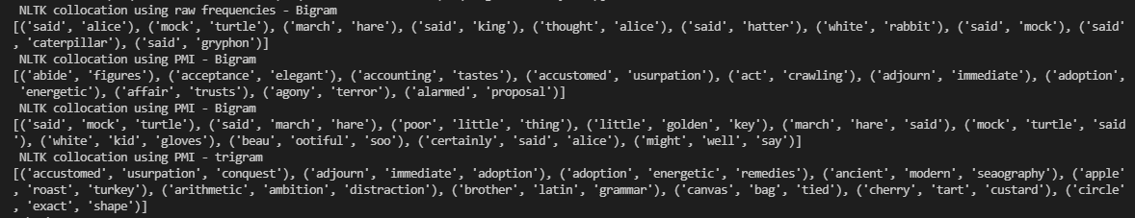

Weighted tag based phrase extraction

Toy corpus

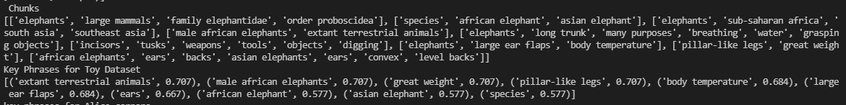

Alice corpus



**Topic Modeling**

**For Toy corpus**

LSI Gensim model - TFIDF

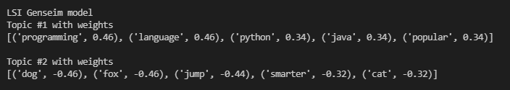

LSI custom built model

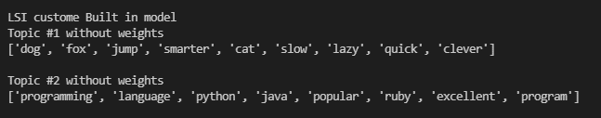

LDA genism model

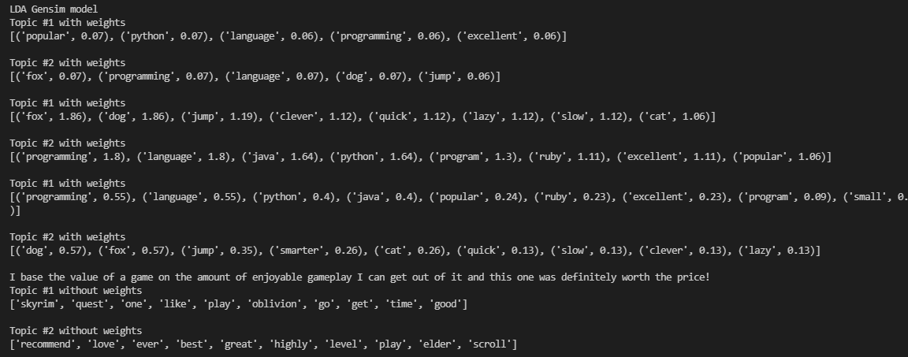

**For Amazon skyrim reviews**

LDA genism model

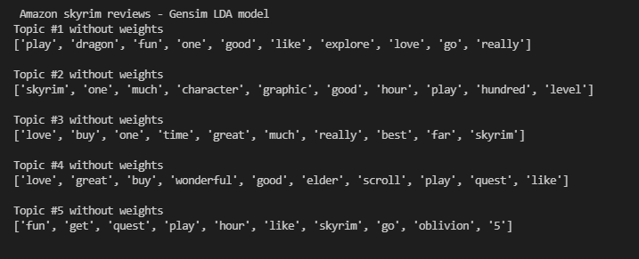

Sklearn LDA

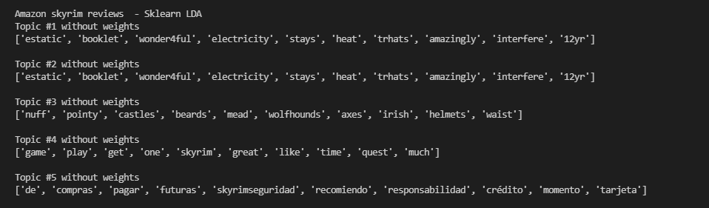

Sklearn Non Negative Matrix Factorization

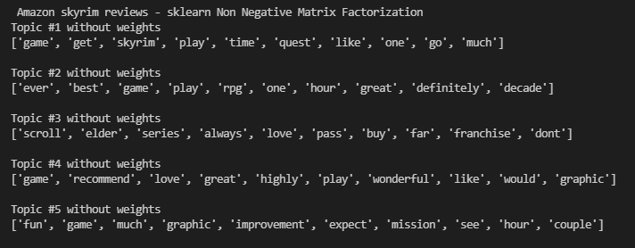

**Document Summarization**

Gensim summarization model has removed from genism. So its result not included here.

Custom summarization algorithm result



Pagerank - networkX



Generic LSA based text summarizer result



Generic TextRank based text summarizer

